October 4th, 2023 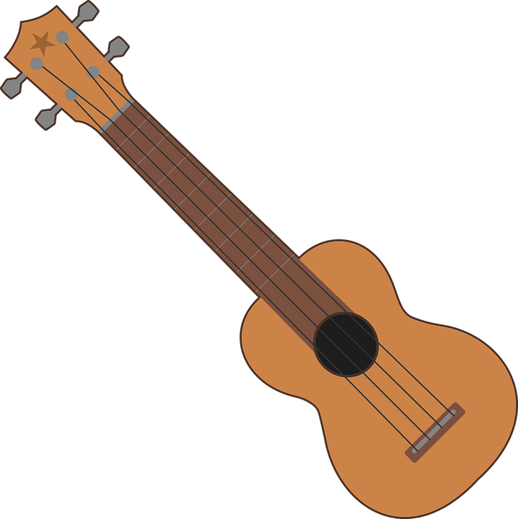
Dear Music Parents,
I want to let you know that your child has been working hard in music class, learning the ukulele. It has been VERY fun and exciting to see the students learning chords, and playing and singing at the same time. They are working on hand/eye coordination, reading music notes on the page as well as working together as a team to play all at the same time.
I have been asked by several students how and where to buy a ukulele. I told the students they make great holiday and birthday gifts! Here is the info:

- All of our 31 ukuleles and cases were purchased years ago by Northern Concrete in Denmark and donated to the Elementary Music Department. We are truly grateful.

- The ukuleles are called Diamond Heads and come in various colors. They can be purchased locally at Instrumental Music Company.. Ask your child what color they like. They are approximately $40.00 and come with a vinyl case. I have a hard case for every ukulele to help keep them protected for many years to come. If you are interested in a hard case, that is an additional $40.00. Please shop local and do not buy from a box store. It’s important to invest in a quality instrument for a great sound.

- I recommend a book/ cd called Children’s Ukulele Method By Mel Bay. This book is $15.00 and comes with a CD for the students that we have been using in class. This can also be purchased at the Instrumental Music Company.
- I suggest that students use Youtube’s “ Best Online Ukulele Tuner” to help them tune their instruments. This is VERY important for the success of playing. You can also purchase a tuner, but this site is free and the kids have used this in class. There are alot of free sites on youtube as well.
This is a wonderful activity for students to work on self-discipline and work on achieving goals by themselves. It’s a fun, happy instrument that is really upbeat and makes kids smile . It is smaller and in size and not intimidating to play. I encourage you to consider this investment if your child is interested. I might be adding some additional classes in summer school to continue working on chords and fun songs to play together.
If you have any questions, the best way to contact me is through my email address at carleyt@denmark.k12.wi.us. It is truly educational and a lot of fun teaching this instrument to your child!
Musically Yours,

Tammy Carley
Elementary Music Teacher

